Food Bank of the Rockies Group Volunteer Application
Please print or write neatly

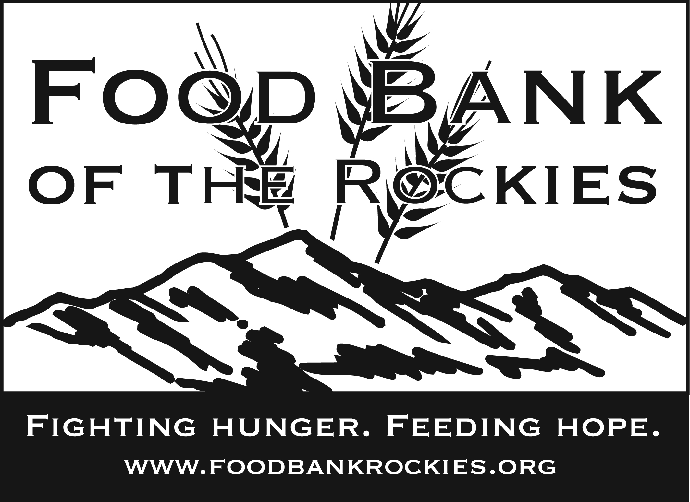
Main Contact Name: |  |  |  |  |  | FBR ID (for FBR use): |  |  |  |  | Date:
Group or Company:

Address: |  |  |  |  |  | City: |  |  |  |  | Zip:
Primary Phone: |  |  |  |  |  | Cell Phone or Pager:
Email Address: |  |  |  |  |  | Fax:
Is Your Group with a School: |  | School Name:
Grade of School Group: |  | Ages of School Group: |  |  |  |  |  | Number in Group:
Facebook: |  | Twitter: |  |  |  |  |  | Blog/Website:
How did your group hear about Food Bank of the Rockies?
Many businesses or clubs make donations that match gifts of time and/or money. In addition, many grants are based on donating to organizations with which employees, retirees or members are involved. Are you aware of any matching gift or grant opportunities within your organization? If so, which ones?

Are you volunteering for VIP credits for a Food Bank member agency? |  |  |  |  |  | If yes, please provide the agency name.
Which area would you like to help in? (Please circle all that apply)

Reclamation Distribution USDA Kitchen Nutrition Network Office Nome

Days/Shifts Available? (Volunteer shifts are 9:00 AM -11:30 AM and 12:30 PM - 3:30 PM, Monday – Friday)
Would you like to receive our newsletter by email? |  |  |  |  |  |  | Would you like to receive volunteer information by email?
Are there any additional items or health issues you’d like to share with us?

Adult/Child Photographic Release Form
Group Adult/Child Photo Release Form

Do you give your consent for any films, videos or photographs taken of your group to be used by Food Bank of the Rockies or its participating agencies in publicity and/or advertising programs?

(Please circle) Yes No

If yes, you agree to release Food Bank of the Rockies, its participating agencies and consultants from any liability in connection with the use of such materials.

Authorized Signature |  |  | Printed Name |  |  |  |  |  |  | Date
Please list anyone in your group who SHOULD NOT be photographed and include a brief identifying description of them, including color of hair, color of clothing, etc…
Food Bank of the Rockies VolunteerPolicies/Procedures

By signing at the end of this form, I verify that I have read the policies and information below. I understand these policies and will comply with them.

Injury Procedures: In the event of an accident, report the injury to your immediate supervisor or management personnel. Report all injuries—including minor injuries such as bruises and scrapes. Fill out and sign an accident report provided by your supervisor.

Drug Free Workplace Policy: Food Bank of the Rockies prohibits the manufacture, possession, sale or use of any controlled substance while on Food Bank premises, while working or when representing the Food Bank, unless prescribed by a personal physician. Any volunteer who is under the influence of drugs or alcohol will be sent home.

Anti-Theft Policy: Food Bank of the Rockies has zero tolerance for theft. If a volunteer is found stealing, they will be dismissed immediately. Theft is consuming or possessing our inventory that is meant for those in need unless directly given the items by Food Bank staff, or being in the possession of property of the Food Bank, its employees or other volunteers.

Anti-Violence statement: The Food Bank does not tolerate any intimidation, threats or violent acts. This includes, but is not limited to, threatening or hostile behaviors, physical abuse, vandalism, arson, or sabotage. Anyone threatening another’s safety will be dismissed. Anyone feeling threatened should immediately report the incident to the Manager of Volunteer Relations.

Smoking Policy: Persons 18 and older may smoke on Food Bank property in the designated areas only. Persons under 18 may not smoke on Food Bank property, nor leave the property to smoke.

Confidentiality: Food Bank of the Rockies volunteers are required to keep all information they acquire at the Food Bank confidential.

No Employee Benefits: Food Bank volunteers are not considered employees for any purpose, and no type of workman’s compensation, healthcare or employee benefits shall be provided. In the case of an on-job accident, the Food Bank may choose to provide medical coverage only for those costs not covered by a volunteer’s personal medical coverage.

At-Will Relationship: A volunteer’s status may be terminated at anytime by the volunteer, or by Food Bank of the Rockies for any reason, with or without cause.

Training: Certain volunteer activities require special training and volunteers are not to undertake such activities without being properly trained.

Auto Insurance: Volunteers are not to operate personal vehicles for volunteer activities unless they have the minimum amount of liability insurance required by law.

Assumption of Risk: Some Food Bank of the Rockies volunteer activities are potentially hazardous. A volunteer assumes all risks of working in an environment that includes, but is not limited to, lifting heavy boxes, working near moving belts and machinery, walking on or around pallets of product, standing on cement or asphalt, or other potential dangers

Release from Liability: Volunteers release Food Bank of the Rockies and its agents, representatives, trustees, officers, employees and volunteers from any liability arising out of any damage, loss or injury to the volunteer or his/her property incurred as the result of volunteer activities. The volunteer’s estate shall hold harmless the Food Bank and its agents, representatives, trustees, officers, employees and volunteers from any claims or actions by relatives or legal representatives based on death or injury from volunteer activities.

 | Food Bank of the Rockies Policies/Procedures
 | By signing this form, I verify that I have read the policies and information provided. I understand these policies and will comply with them.
Each volunteer must sign this sheet indicating his/her understanding of our policies/procedures. Parent or Guardian must sign for children
Under 18.

 | Print Volunteer Name |  |  | Signature of Volunteer, Parent, Guardian |  |  |  |  | E-Mail or Home Address |  |  |  | Date

