Food Bank of the Rockies Volunteer Application
Please print or write neatly

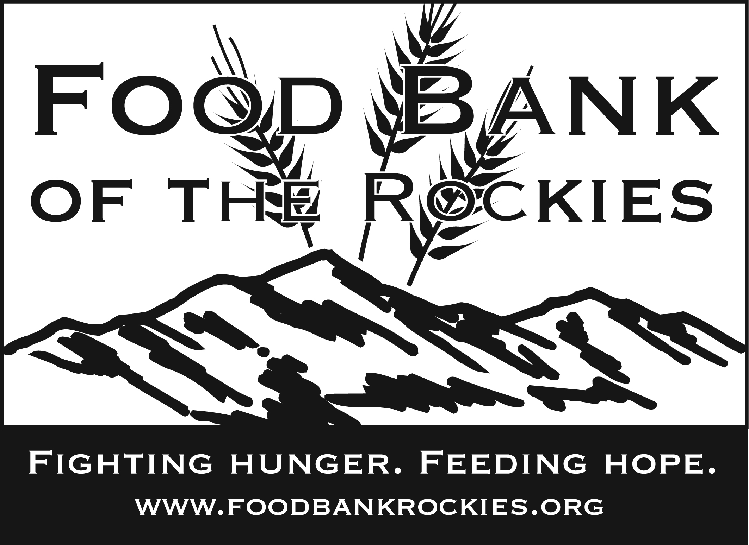
Name: |  |  |  |  |  | FBR ID (for FBR use): |  |  |  | Date:
Address: |  |  |  |  |  | City: |  |  |  | County:
Home Phone: |  |  |  |  |  | Birthday: |  |  |  | Zip:
Work Phone: |  |  |  |  |  | Cell Phone or Pager: |  |  |  | Fax:
Email Address: |  |  |  |  |  | School/Employer: |  |  |  | Year/Grade in School:
Emergency Contact & Relationship: |  |  |  |  |  | Emergency Contact Phone Number:
If you are you volunteering with a group or organization list them here: |  |  |  |  |  | If you are volunteering for VIP credits for an FBR member agency, list the agency here:
Many businesses or clubs make donations that match gifts of time and/or money. Also, many grants are based on donating to organizations with which employees, retirees or members are involved. Please list organizations or businesses with which you are affiliated who might provide matching gifts or grants:

Are you volunteering for school credit? |  |  |  | How many hours? |  |  |  | Contact Person: |  |  | Contact Phone:
Which area would you like to help in? (Please circle all that apply)

Reclamation Distribution Kitchen Nutrition Network Office Nome

Days/Shifts Available? (Volunteer shifts are 9:00 AM -11:30 AM and 12:30 PM - 3:30 PM, Monday – Friday)

Would you like to receive our newsletter by email? |  |  |  |  |  |  | Would you like to receive volunteer information by email?
Are there any additional items or health issues you’d like to share with us?

Adult/Child Photographic Release Form

Do you give your consent for any films, videos or photographs to be taken of you to be used by Food Bank of the Rockies or its participating agencies in publicity and/or advertising programs?

(Please circle) Yes No

If yes, you agree to release Food Bank of the Rockies, its participating agencies and consultants from any liability in connection with the use of such materials.

Signature of Volunteer |  |  |  |  | Printed Name |  |  |  | Date
Signature of Parent or Guardian  (Parent or Guardian must sign if volunteer is under 18 years of age). |  |  |  |  | Printed Name |  |  |  | Date
Optional Statistical Information:

Gender:  Male Female | Marital Status: |  | Profession: |  |  |  | Skills: |  | How did you hear about volunteer opportunities at the Food Bank?

Food Bank of the Rockies Volunteer Policies/Procedures

By signing at the end of this form, I verify that I have read the policies and information below. I understand these policies and will comply with them.

Injury Procedures: In the event of an accident, report the injury to your immediate supervisor or management personnel. Report all injuries—including minor injuries such as bruises and scrapes. Fill out and sign an accident report provided by your supervisor.

Drug Free Workplace Policy: Food Bank of the Rockies prohibits the manufacture, possession, sale or use of any controlled substance while on Food Bank premises, while working or when representing the Food Bank, unless prescribed by a personal physician. Any volunteer who is under the influence of drugs or alcohol will be sent home.

Anti-Theft Policy: Food Bank of the Rockies has zero tolerance for theft. If a volunteer is found stealing, they will be dismissed immediately. Theft is consuming or possessing our inventory that is meant for those in need unless directly given the items by Food Bank staff, or being in the possession of property of the Food Bank, its employees or other volunteers.

Anti-Violence statement: The Food Bank does not tolerate any intimidation, threats or violent acts. This includes, but is not limited to, threatening or hostile behaviors, physical abuse, vandalism, arson, or sabotage. Anyone threatening another’s safety will be dismissed. Anyone feeling threatened should immediately report the incident to the Manager of Volunteer Relations.

Smoking Policy: Persons 18 and older may smoke on Food Bank property in the designated areas only. Persons under 18 may not smoke on Food Bank property, nor leave the property to smoke.

Confidentiality: Food Bank of the Rockies volunteers are required to keep all information they acquire at the Food Bank confidential.

No Employee Benefits: Food Bank volunteers are not considered employees for any purpose, and no type of workman’s compensation, healthcare or employee benefits shall be provided. In the case of an on-job accident, the Food Bank may choose to provide medical coverage only for those costs not covered by a volunteer’s personal medical coverage.

At-Will Relationship: A volunteer’s status may be terminated at anytime by the volunteer, or by Food Bank of the Rockies for any reason, with or without cause.

Training: Certain volunteer activities require special training and volunteers are not to undertake such activities without being properly trained.

Auto Insurance: Volunteers are not to operate personal vehicles for volunteer activities unless they have the minimum amount of liability insurance required by law.

Assumption of Risk: Some Food Bank of the Rockies volunteer activities are potentially hazardous. A volunteer assumes all risks of working in an environment that includes, but is not limited to, lifting heavy boxes, working near moving belts and machinery, walking on or around pallets of product, standing on cement or asphalt, or other potential dangers

Release from Liability: Volunteers release Food Bank of the Rockies and its agents, representatives, trustees, officers, employees and volunteers from any liability arising out of any damage, loss or injury to the volunteer or his/her property incurred as the result of volunteer activities. The volunteer’s estate shall hold harmless the Food Bank and its agents, representatives, trustees, officers, employees and volunteers from any claims or actions by relatives or legal representatives based on death or injury from volunteer activities.

Acceptance of Volunteer Position (Parent or Guardian must sign if volunteer is under 18 years of age).
Signature of Volunteer | Printed Name | Date
Signature of Parent or Guardian of Volunteer | Printed Name | Date

